**Twitter sentiment Analysis**

**What is sentiment analysis?**

* In essence, it is the process of determining the emotional tone behind a series of words, used to gain an understanding of the the attitudes, opinions and emotions expressed within an online mention.



* Sentiment analysis is extremely useful in social media monitoring as it allows us to gain an overview of the wider public opinion behind certain topics.
* Examples: we can understand sentiments through example of any social media platform

1. Positive sentiment would include all consumptions such as likes, comments, and shares etc.
2. Negative sentiment includes the chance to report, hide, block a post.
3. Neutral sentiment includes a click or a scroll but has not follow through for a consumption i.e. someone just checked out the image.

**What is twitter sentiment analysis?**

* Sentiment Analysis is a technique used in text mining. It may, therefore, be described as a text mining technique for analysing the underlying sentiment of a text message, i.e., a tweet. Twitter sentiment or opinion expressed through it may be positive, negative or neutral. However, no algorithm can give you 100% accuracy or prediction on sentiment analysis.
* sentiment analysis of Twitter data may also depend upon sentence level and document level.

**Why twitter sentiment analysis?**

Sentiment Analysis Dataset Twitter has a number of applications:

* **Business**: Companies use Twitter Sentiment Analysis to develop their business strategies, to assess customers’ feelings towards products or brand, how people respond to their campaigns or product launches and also why consumers are not buying certain products.
* **Politics**: In politics Sentiment Analysis Dataset Twitter is used to keep track of political views, to detect consistency and inconsistency between statements an

actions at the government level. Sentiment Analysis Dataset Twitter is also used for analysing election results.

* **Public Actions**: Twitter Sentiment Analysis also is used for monitoring and analysing social phenomena, for predicting potentially dangerous situations and determining the general mood of the blogosphere.

**Prerequisites:**

Python must be installed.

Twitter Authentication to access API.

**Packages used:**

* Tweepy: tweepy is the python client for the official Twitter API
* Wordcloud: help us to analyse texts and to quickly visualize the keywords as a word cloud.
* Textblob: textblob is the python library for processing textual data
* Pandas: data analysis and manipulation tool.
* numpy: library for scientific computing in Python
* Matplotlib: multi-platform library for visualization.

**Algorithm:**

1. START
2. Authenticate with twitter API and stream the tweets.
3. Clean the tweets.
4. Calculate the polarity.
5. Anaylze the sentiments on base of the score of polarity.
6. Calculate the percentage and plot the graph for sentiments.
7. END

**Flowchart:**

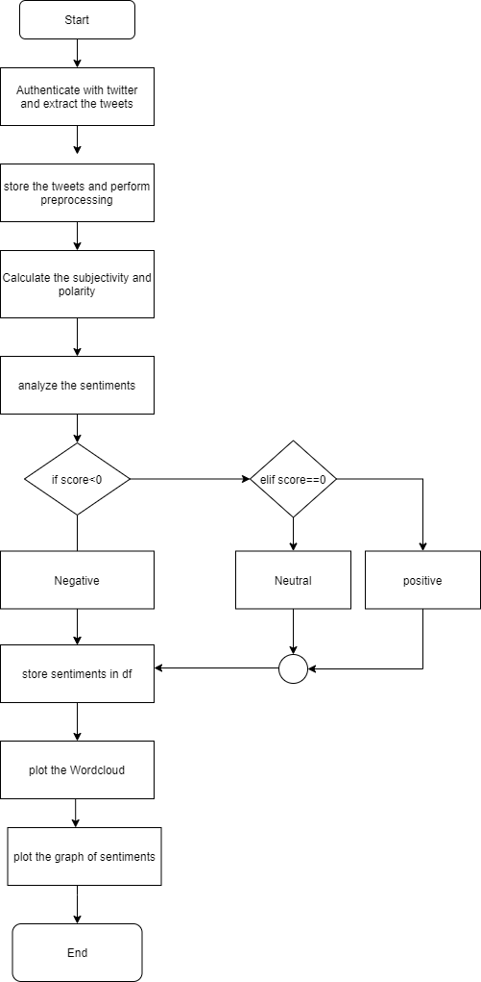

**OUTPUTS:**

**WordCloud for Flipkart:**

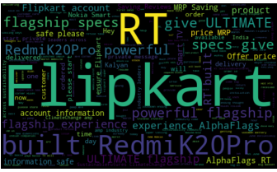

**Flipkart Sentiment Analysis based on polarity:**

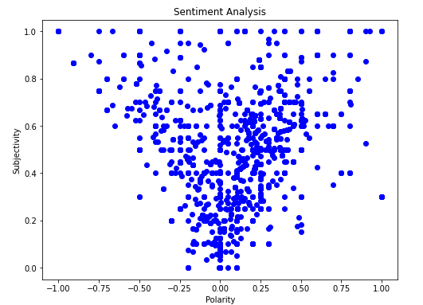

**Value Counts for sentiments of flipkart:**

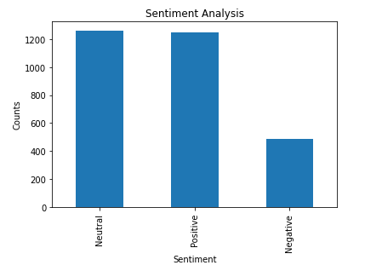

**Wordcloud for Amazoin:**

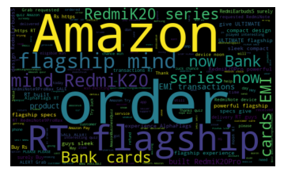

**Value Counts for sentiments of Amazonin:**

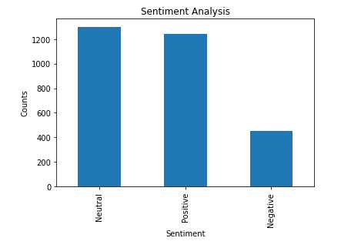

**Amazonin Sentiment Analysis based on polarity:**

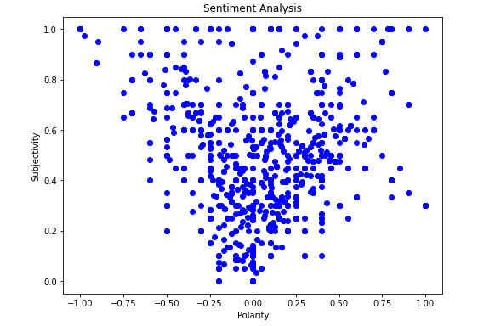

**Wordcloud for Snapdeal:**

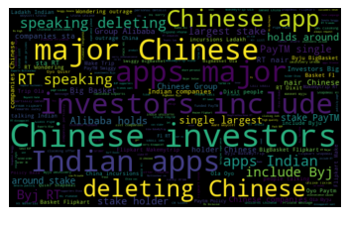

**Snapdeal Sentiment Analysis based on polarity:**

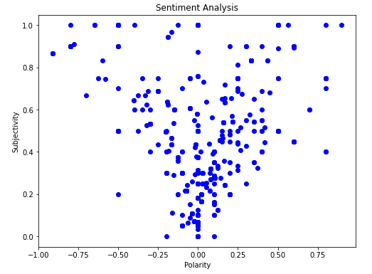

**Value Counts for sentiments of Amazonin:**

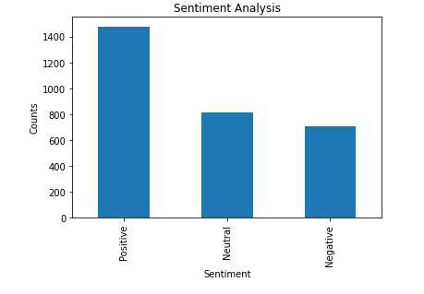

**LIMITATIONS:**

1. The Twitter Search API can get tweets upto a maximum of 7 days old.

2. Cannot get 100% efficiency in analysing sentiment of tweets.

**FUTURE WORK:**

* Detect sarcasm in tweets
* Analyse images for emotions.
* Find no of mentions of n particular organizations.
* Parallelizing code.

**References:**

<https://www.digitalvidya.com/blog/twitter-sentiment-analysis-introduction-and-techniques/>

<https://support.yapsody.com/hc/en-us/articles/360003291573-How-do-I-get-a-Twitter-Consumer-Key-and-Consumer-Secret-key-> .